**Assignment 16.3**

1.Execute Session 16 - Assignment 1 (Machine and Sensor data analysis) using Reduce side join and compare which join is faster in normal conditions.

**Driver**

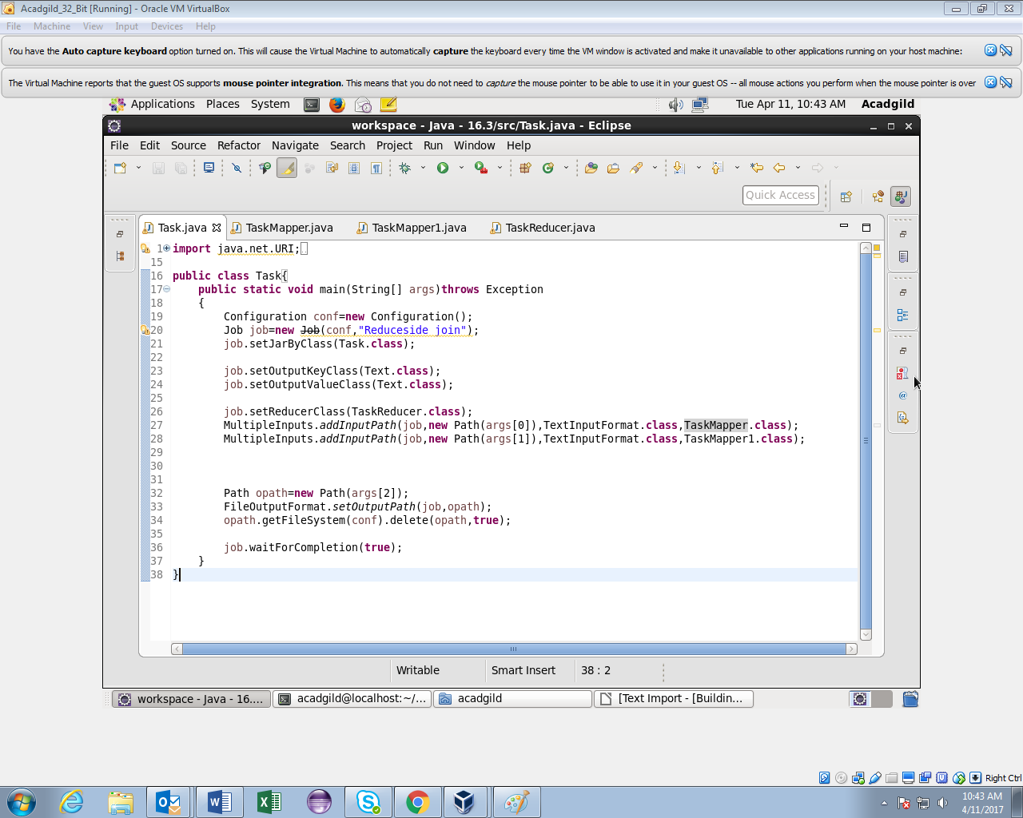

**Mapper1**

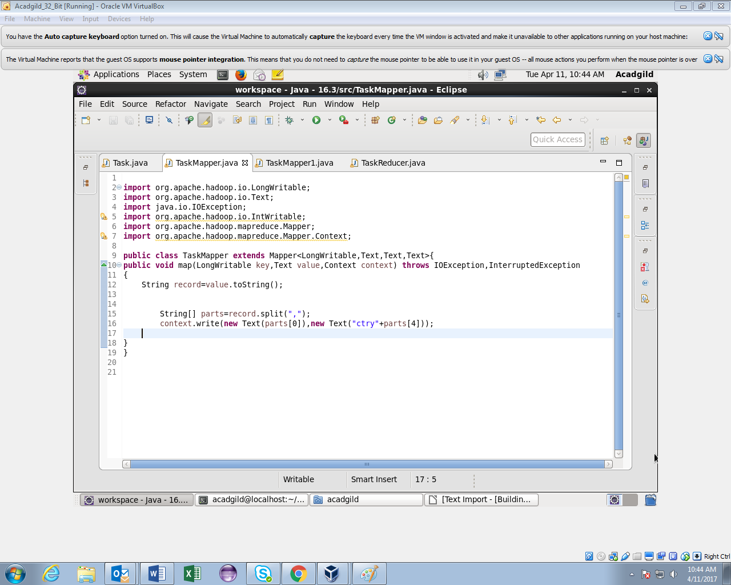

**Mapper2**

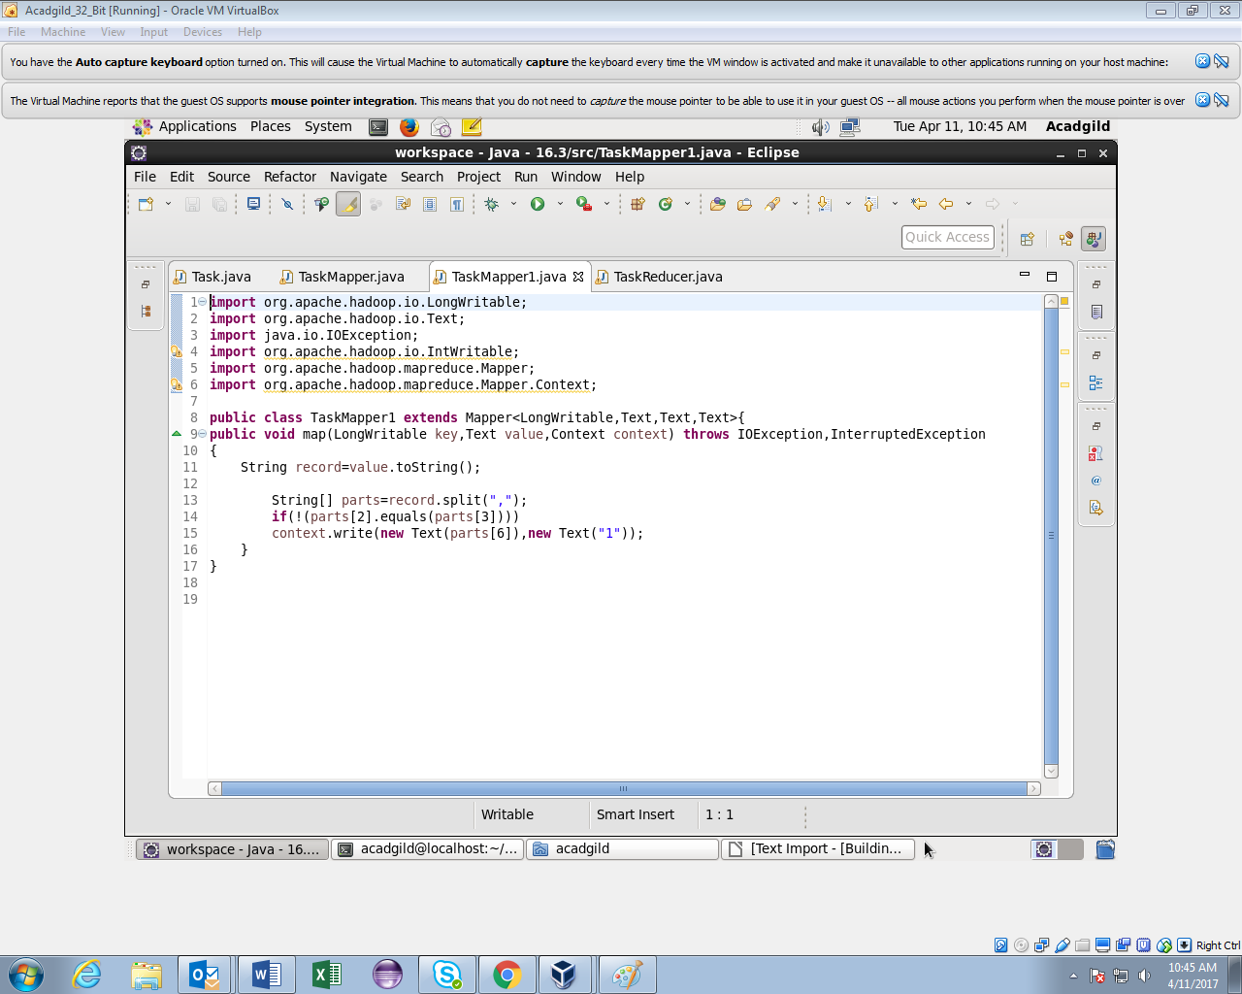

**Reducer**

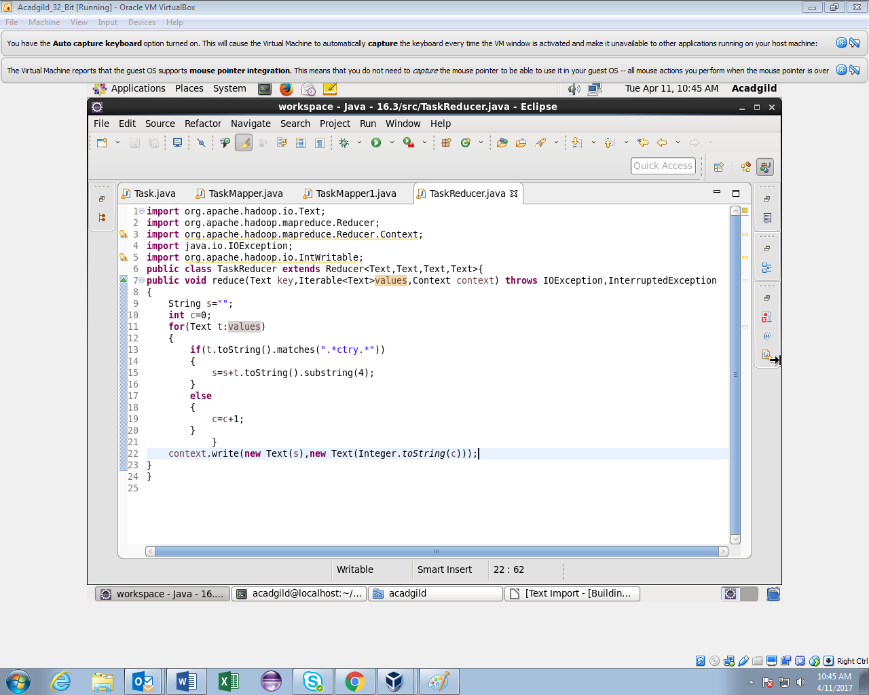

**Running jar**

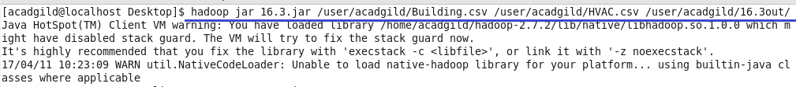

**Output**

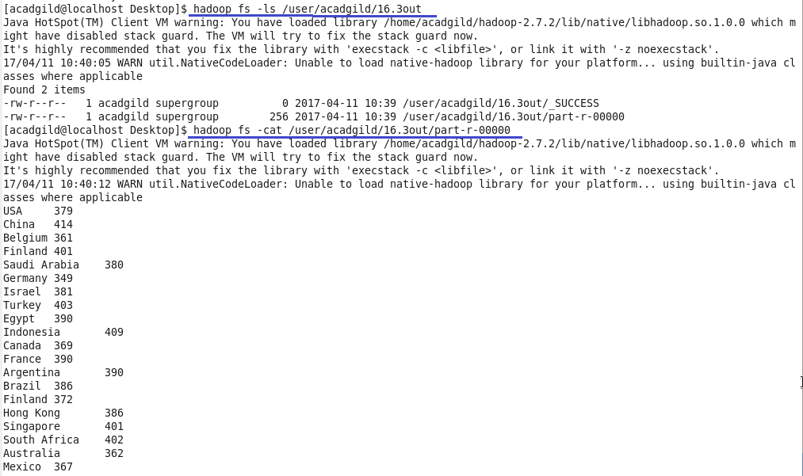

**Comparison between joins**

1.Joining in the reduce side will take place after the completion of map phase.So, the data will be taken from different mappers.

2.Reduce side joins are simpler than map side joins because the input datasets need not be structured.

3.It is slower and less efficient than the map side join.